Experiment - 1
Name : ADITYA PRASAD SAP ID : 590032113
Date : 18/8/26 Batch : 15 programme : B.Tech CSE
- Setting up of the platform
We can do C programming online or offline according to the needs. It is required for us to keep working on a Linux Environment.
Online: Cocalc.ai
Offline: windows, linux nation OS
Methods: Dual boot, Single boot, Bootable Pendrive, VM

- Virtual Machine Manager (Hypervisor)
Type-1 (Baremetal)
What : Bare metal refers to a physical computer server that is completely dedicated to a single user or organization. Unlike virtual servers or virtual machines (VMs), bare metal has no shared resources and no pre-installed virtualization software (hypervisor) running between the operating system and the hardware.
E.g. The Virtual Machine (VM) Setup
Type-2 (Hosted)
What : a S software application, service, system, or infrastructure is managed and delivered from a remote server rather than being run locally on your own physical hardware .
E.g Oracle Virtualbox, VM Ware.
We would be using Oracle Virtualbox.

- Installation of VMM & VM
Step-1: Download Oracle Virtual Box (paste the link, attach screenshot)
Step-2: Download Kali Linux VM (paste the link, attach screenshot)
Step-3: Extracted the Kali Linux downloaded file
Step-4: Install Virtualbox
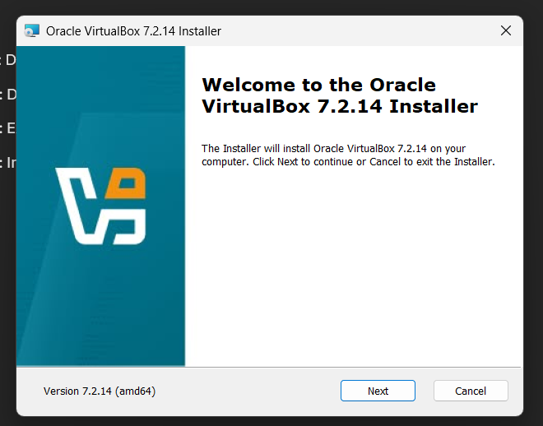
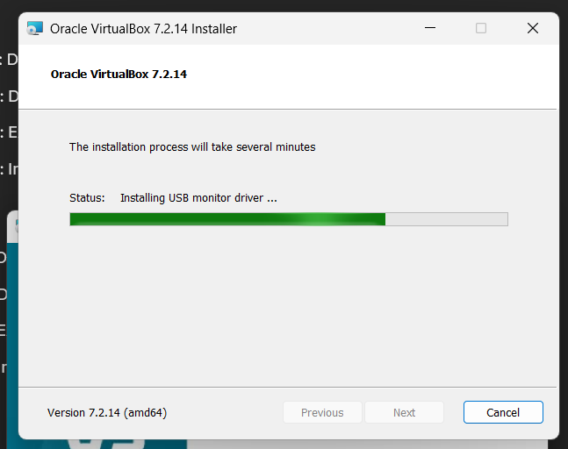
Step-5: Open Virtual box
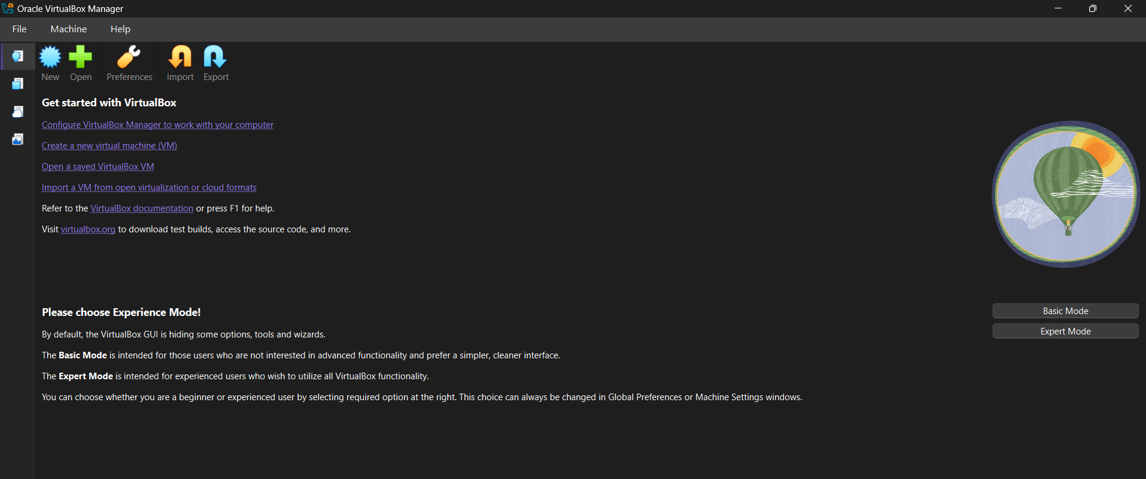
Step-6: Opening the saved VM
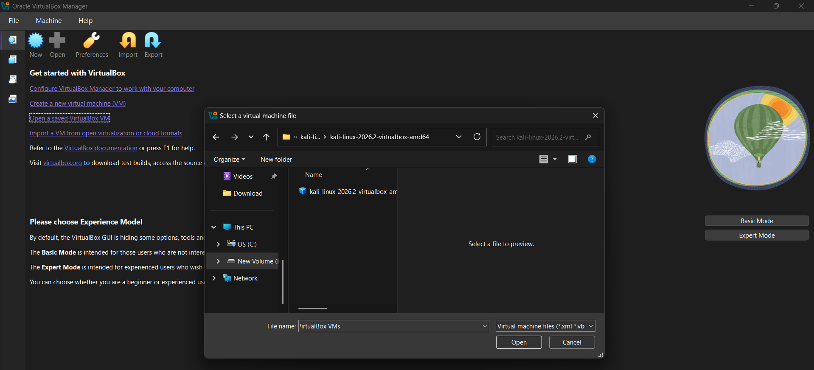
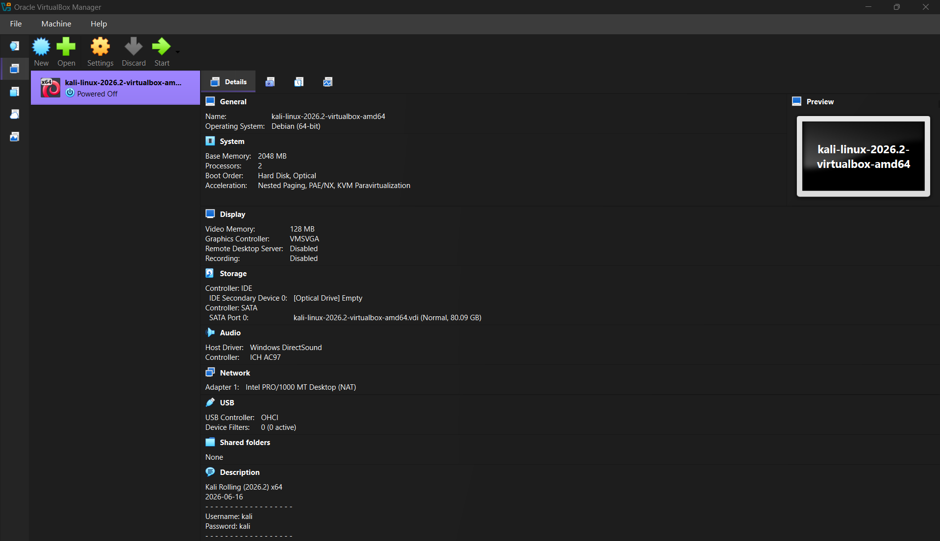
Step-7: Start the VM
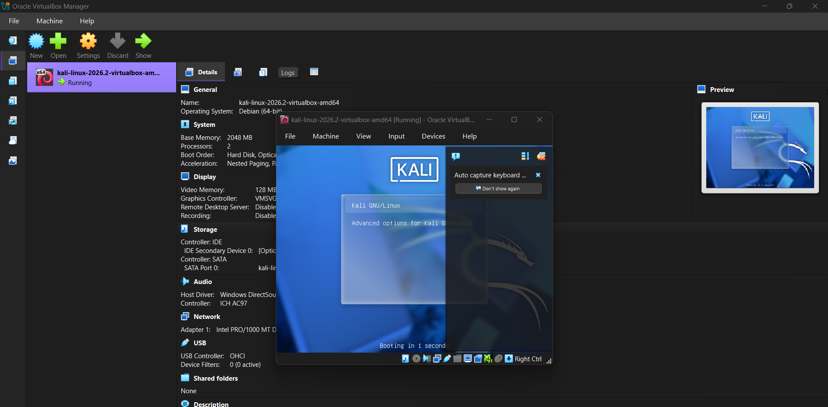
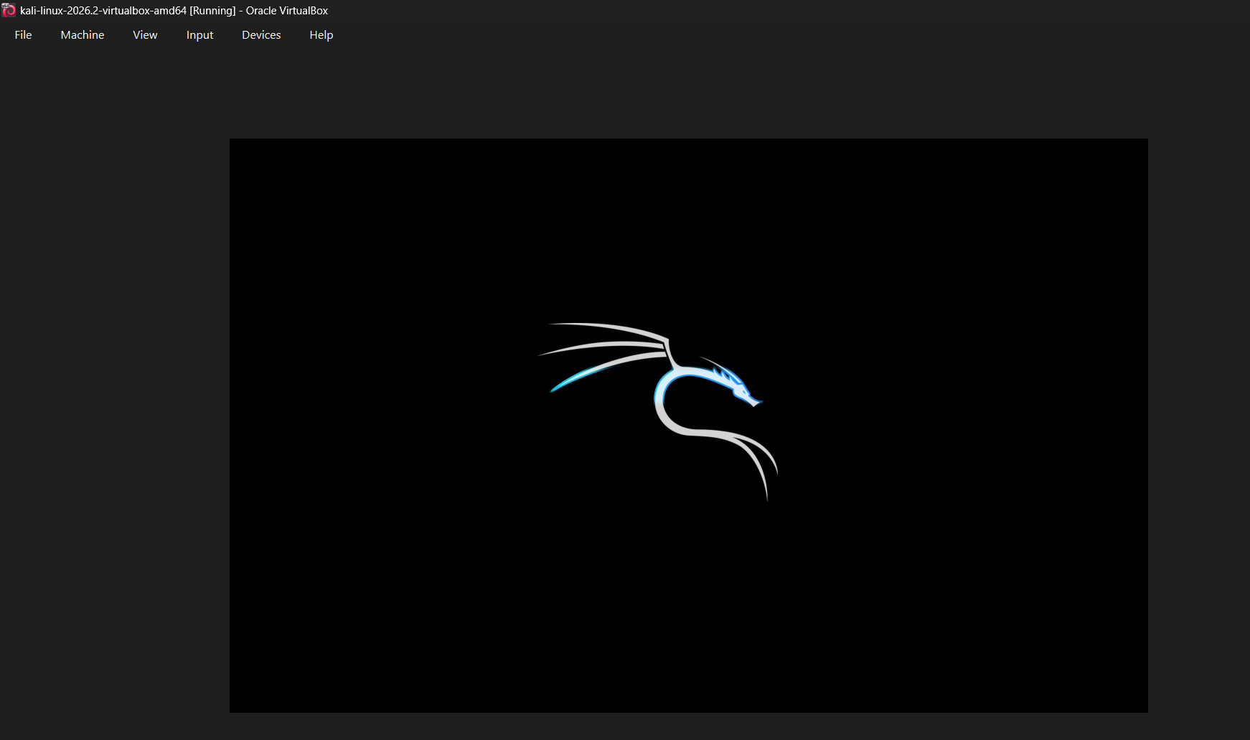
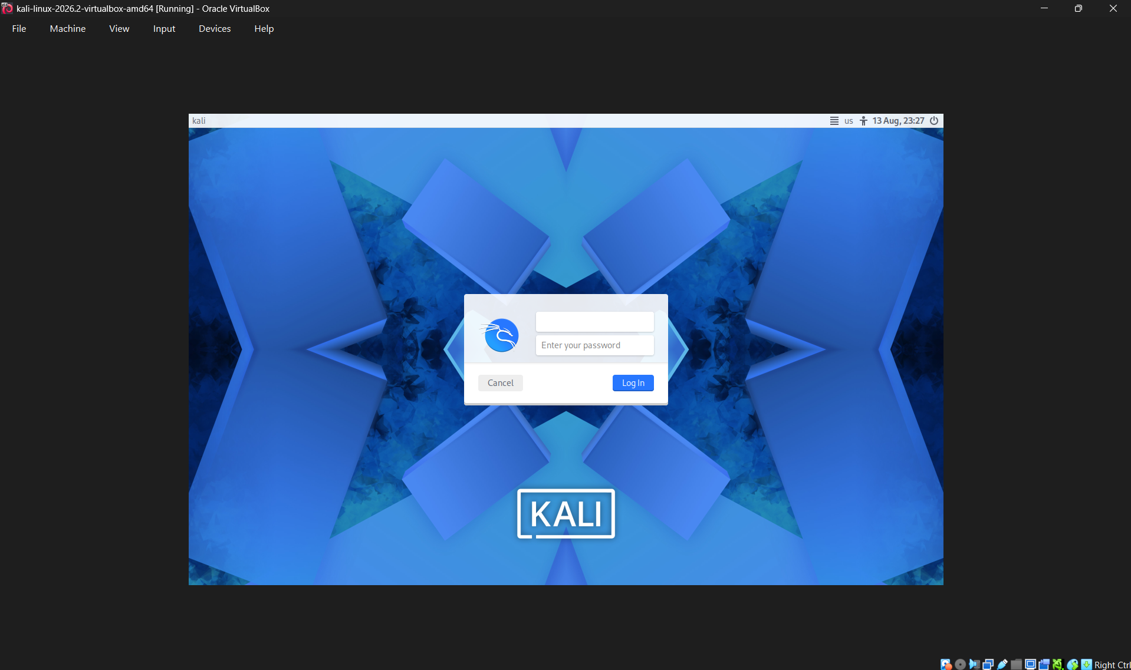

Thus the installation of VMM (Hypervisor Type-2 Oracle VirtualBox) & VM (Kali Linux) is completed.

